**NST31042 - Practical for Scaling and Connecting**

Department of Information & Communication Technology Faculty of Technology, SEUSL

**Lab Sheet – 11**

**Registration Number: -SEU/IS/19/ICT/046**

**Title:** Dynamic NAT Configuration

Aim:

1. Configure and Familiar with Dynamic NAT Configuration for IPv4
2. Configure and Familiar with PAT Configuration

**Task:**

1. Build the Network and Configure Basic Device Settings
2. Configure and verify Dynamic NAT for IPv4
3. Configure and verify PAT

**Introduction:**

Dynamic NAT, short for Dynamic Network Address Translation, is a way for your router to share a single public IP address with multiple devices on your home network. Imagine it like an apartment building with one mailbox on the street (public IP) but many individual mailboxes inside (private IPs).

**Question 01**

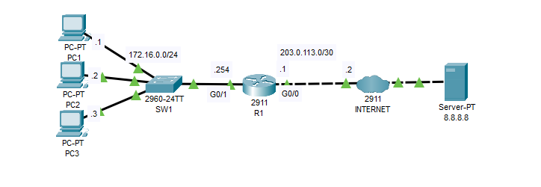

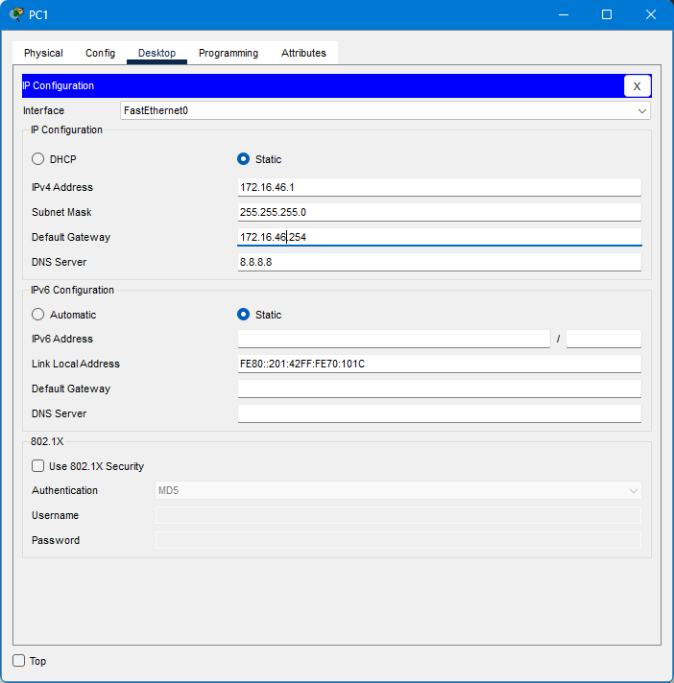

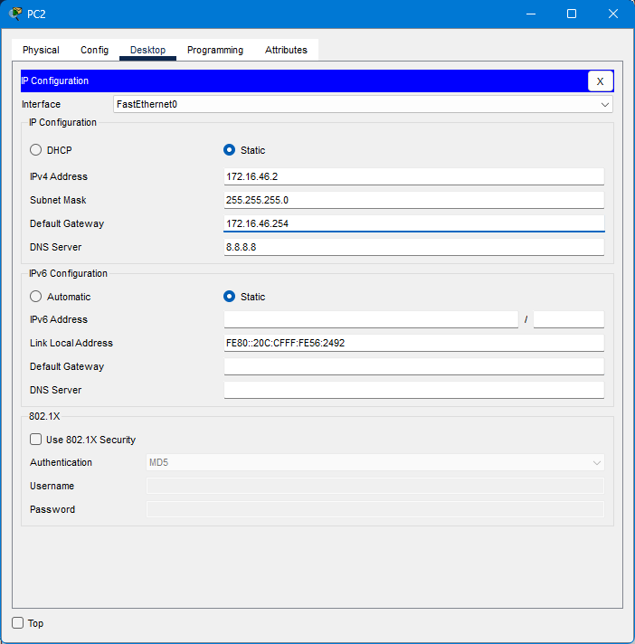

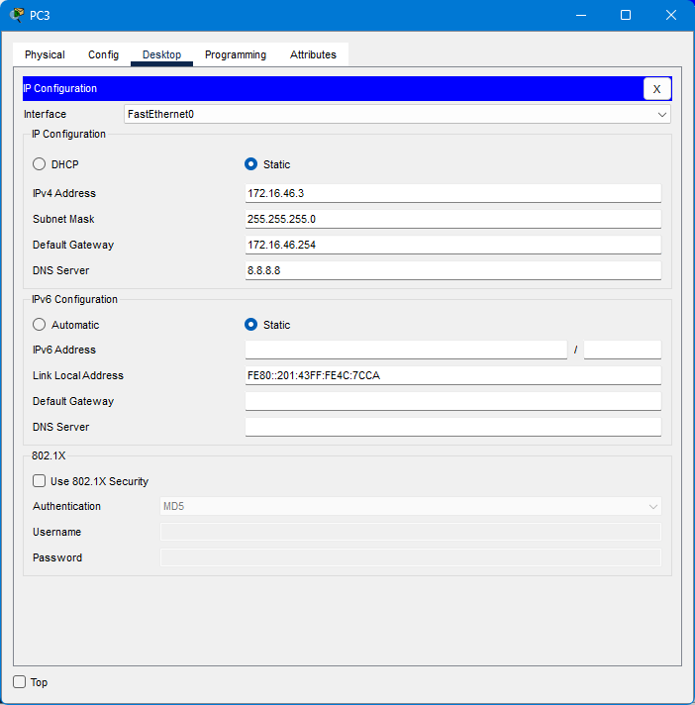

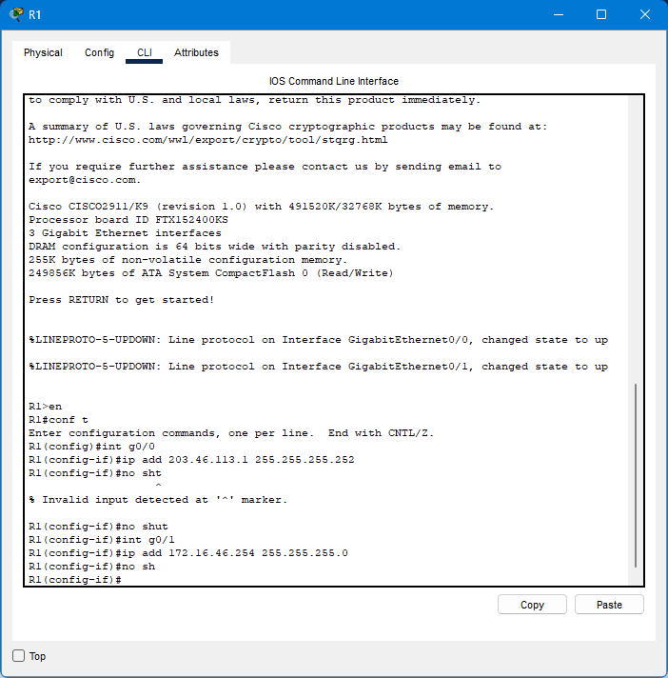

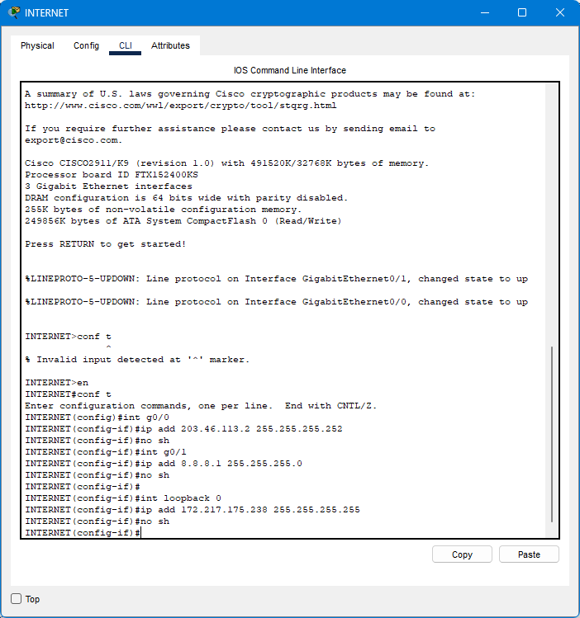

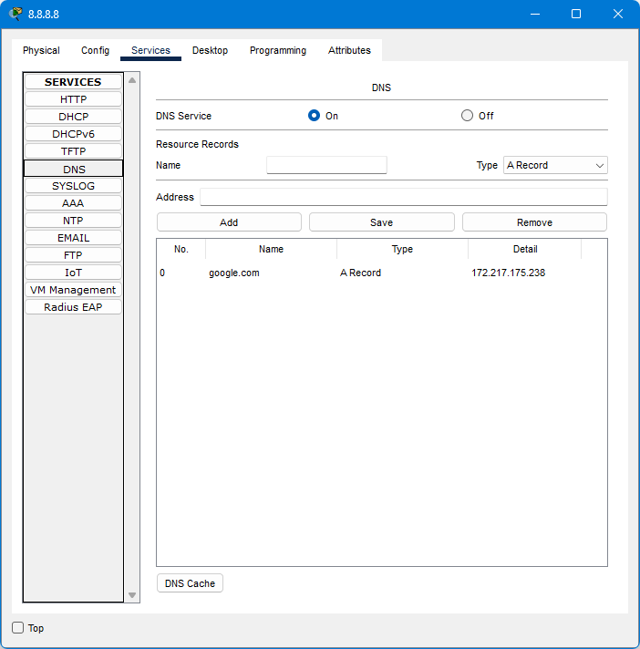

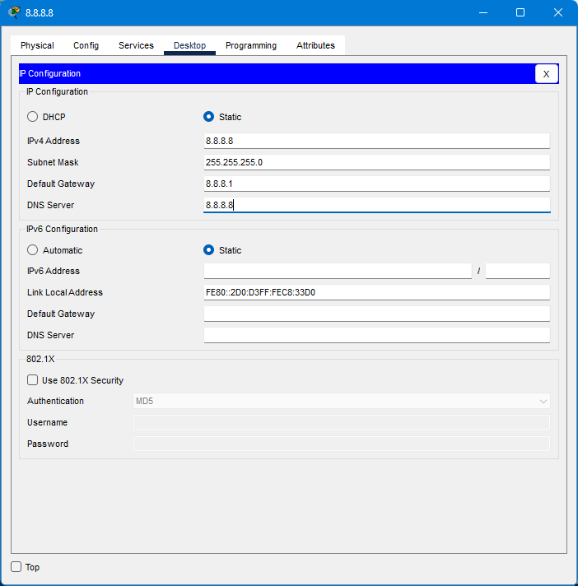

* 1. Configure dynamic NAT on R1.
     + 1. Configure the appropriate inside/outside interfaces.
       2. 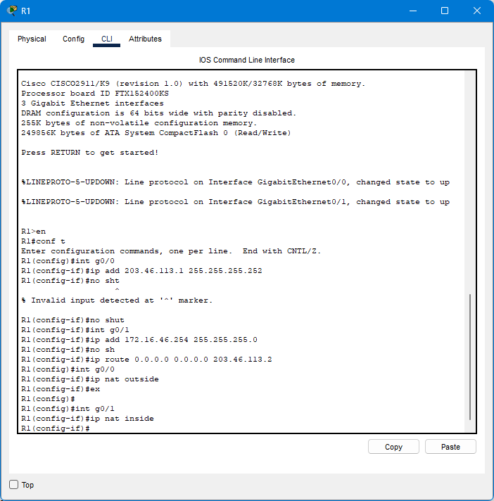

Translate all traffic from 172.16.0.0/24

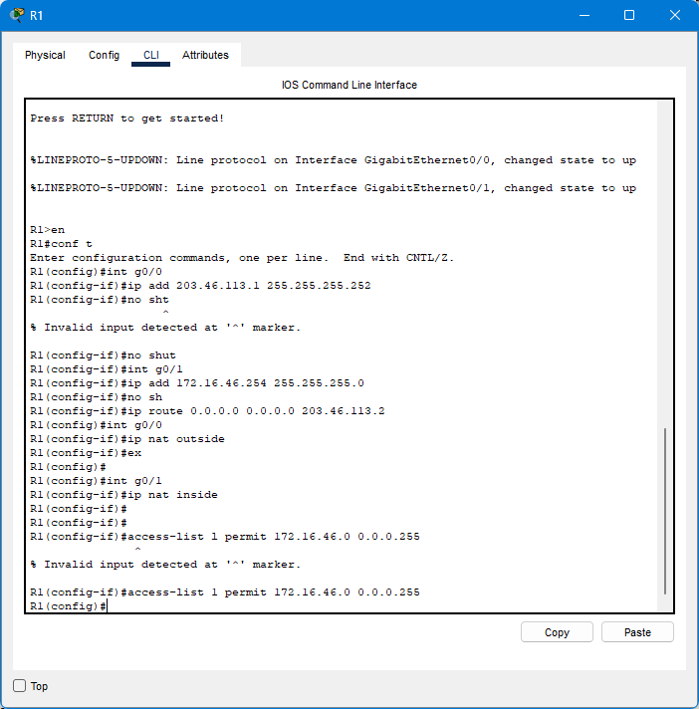

Create a pool of 100.0.0.1 to 100.0.0.2 from the 100.0.0.0/24 subnet

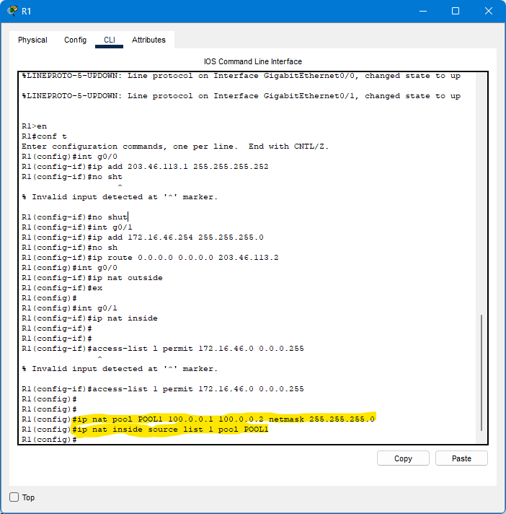

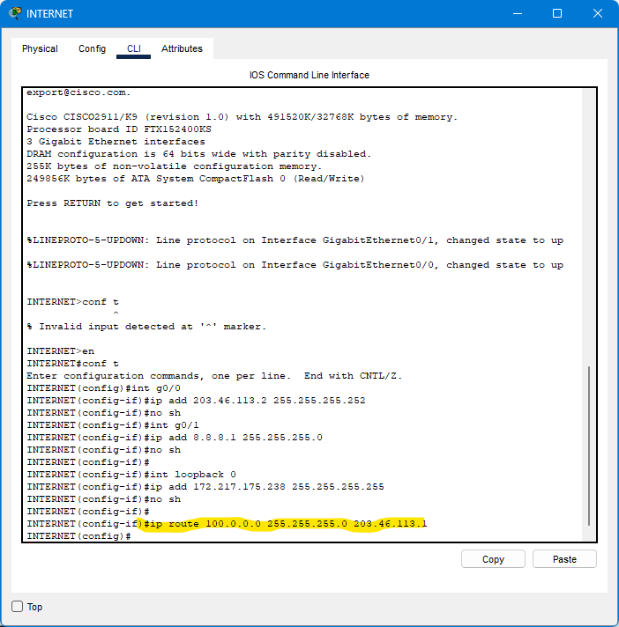

Ping google.com from PC1 and PC2. Then, ping it from PC3. What happens to PC3's ping?

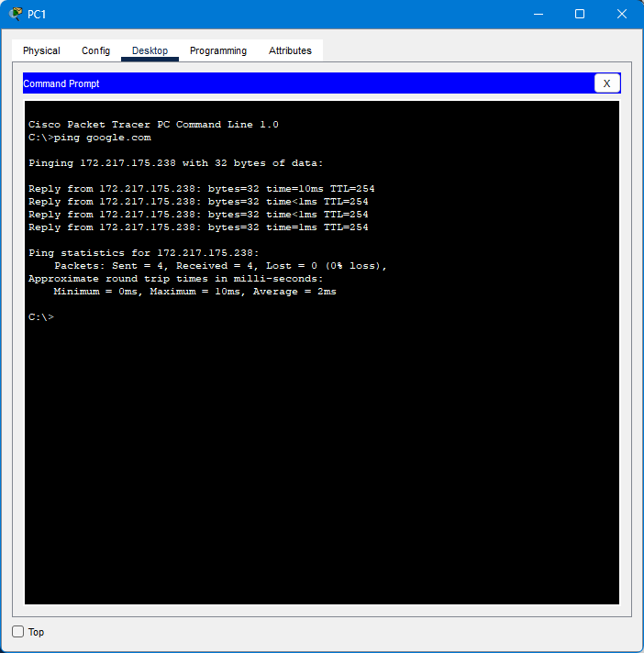

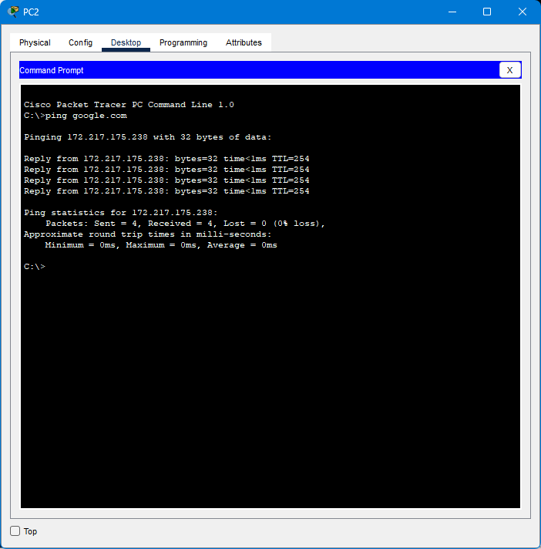

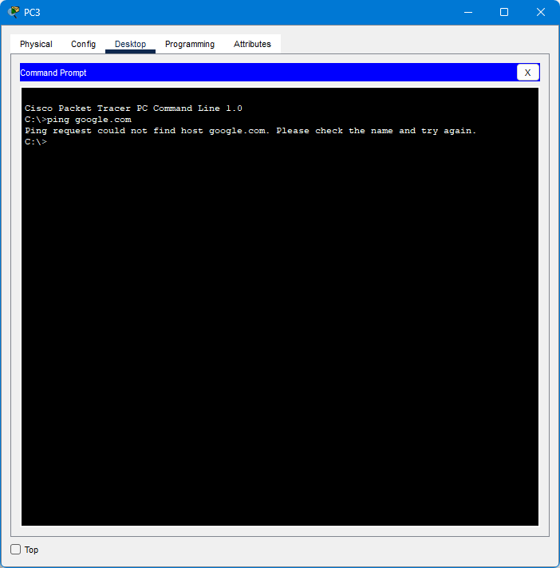

***Because of the pool Range (100.0.0.1 to 100.0.0.2) we gave only two pcs So PC3 is not ping***

Clear the NAT translations and remove the current NAT configuration. Switch the configuration to PAT using R1's public IP address

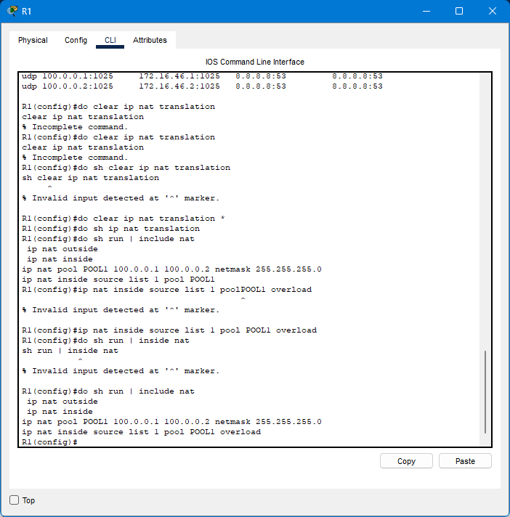

Ping google.com from each PC. Do the pings work?

Examine the NAT translations on R1.

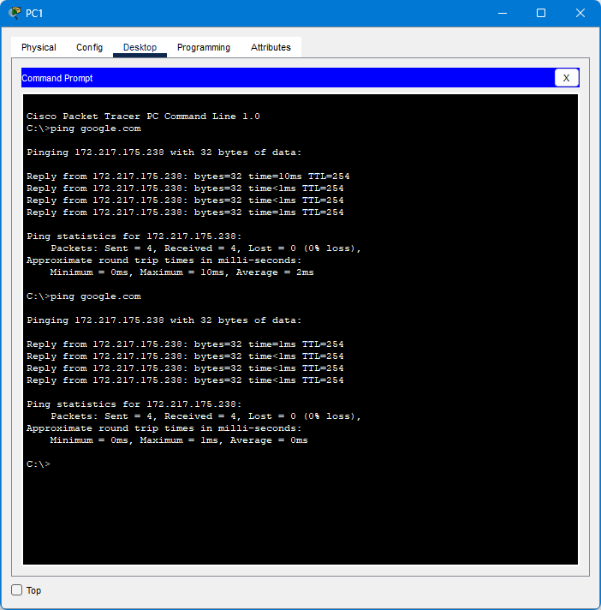

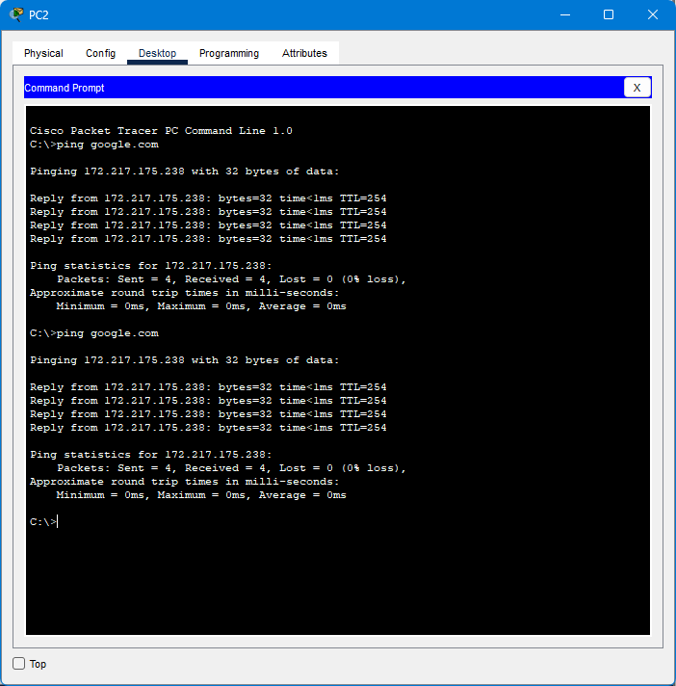

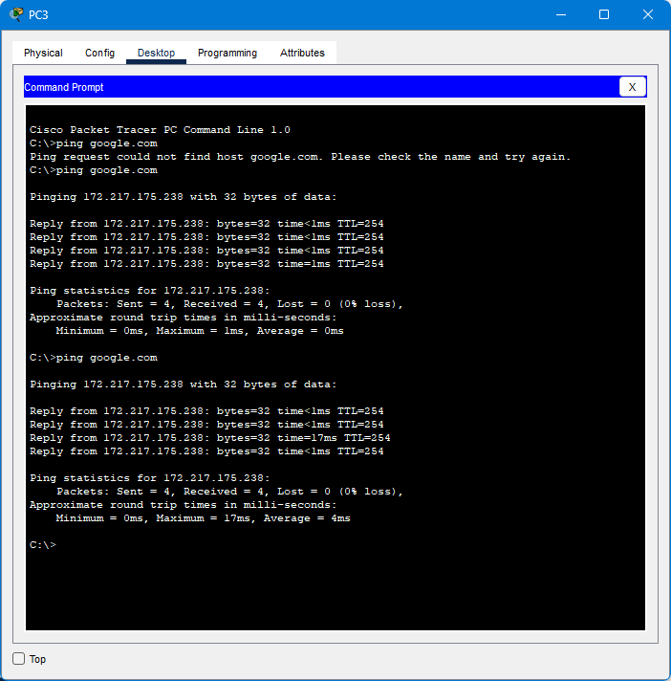

Discussion

* From this lab sheet I learnt about Configure and verify Dynamic NAT and verify PAT. This is little bit easy lab sheet . I did it once.

**Pool is :**

Network pools refer to a grouping of network resources or addresses used for efficient management in various networking environments. In virtualization, they streamline the allocation of IP addresses to virtual machines or containers, ensuring optimal resource utilization and simplified administration. Additionally, in internet connectivity scenarios, network pools are often employed in conjunction with network address translation (NAT) to enable multiple internal devices to access the internet using a shared pool of public IP addresses. Overall, network pools provide a flexible and scalable approach to managing network resources in diverse networking setups